Operating Systems Fundamentals
Activity 1: CPUs Q&A
- Complete the table below:

Intel CPU line | User case | Technical features
Atom | Atom is mainly used in netbooks, nettops, and embedded applications | Use less electricity and cost less money  Max. CPU clock rate: 600 MHz to 4.0 GHz

AMD CPU line | User case | Technical features

- What are the current sockets used for Intel and AMD?

- How do integrated graphics in a CPU compare to dedicated graphics cards?

Activity 2: RAM Q&A
- What is the difference between volatile and non-volatile memory, and how does RAM fit into this distinction?

- What does latency in RAM refer to, and how does it affect performance?

- What is the purpose of buffered vs. unbuffered RAM, and where is each used?

- What is the significance of ECC RAM (Error-Correcting Code), and in what situations would it be preferred over regular RAM?

Activity 3: Storage Q&A
- What is the difference between primary and secondary storage?

- How does a Hard Disk Drive (HDD) work, and what are its main components?

- What are the key differences between SSDs (Solid-State Drives) and HDDs?

- How does a Solid-State Drive (SSD) improve a computer's performance compared to an HDD?

Activity 4: Motherboards Q&A
- How does the motherboard's chipset affect system performance?

- What components are typically connected to the motherboard?

- What are PCIe slots, and why are they important on a motherboard?

- How does the number of RAM slots on a motherboard impact the system's memory upgrade potential?

Activity 5: PSUs Q&A
- How do you determine the wattage needed for a PSU in a computer build?

- What are the differences between a modular and non-modular PSU?

- What is the significance of 80 Plus certification, and how does it affect PSU efficiency?

- What are the key components inside a PSU, and how do they contribute to its functionality?

Activity 6: I/O devices Q&A
- What is the primary function of input and output devices in a computer system?

- How do input devices differ from output devices?

- What role does USB play in connecting input/output devices to a computer?

- In what ways do external storage devices like USB flash drives function as input and output devices?

Activity 7: GPUs Q&A
- What are the key differences between integrated GPUs and dedicated GPUs?

- What are CUDA cores, and how do they contribute to GPU performance?

- How does GPU overclocking improve performance, and what are the potential risks involved?

- What factors should you consider when upgrading your GPU in an existing system?

Activity 8: Cooling systems Q&A
- What components in a PC generate the most heat?

- What are the advantages and disadvantages of air cooling compared to liquid cooling?

- What are the potential risks of using liquid cooling in a PC system?

- How does cooling impact the performance of an overclocked CPU or GPU?

Activity 9: PC cases Q&A
- What is the primary function of a PC case?

- Why might you choose a case with support for ATX, mATX, or ITX motherboards?

- What is the difference between intake and exhaust fans in a PC case?

- What factors should you consider when selecting the size of a PC case?

Activity 10: Builds Q&A
- Which option is the most cost-effective: a vendor-built PC, a pre-built PC, or building a PC from scratch?

- What are the key advantages of purchasing a vendor-built PC instead of a pre-built or custom-built PC?

- What are the potential downsides of purchasing a pre-built PC in terms of component quality and pricing?

- What are the common challenges and risks associated with building your own PC?

Activity 11: OS types Q&A
Complete the table:
OS Type | Examples
Real-time

Multi-user

Distributed

Embedded

Multi-tasking and single-tasking

Activity 12: Linux Q&A
Complete the tables:
Distro | Current version | Key features | Minimum spec requirements

Native application | Description

Activity 13: Windows Q&A
Complete the tables:
Version | Editions available | Key features | Minimum spec requirements

Native application | Description

Activity 14: Apple Q&A
Complete the tables:
Version | Latest point release | Key features | Minimum spec requirements

Native application | Description

Activity 15: Android Q&A
Complete the tables:
Version | Latest point release | Key features | Minimum spec requirements

Native application | Description

Activity 16: BIOS vs UEFI Q&A
- What is the main difference between BIOS and UEFI?

- Which boot process is faster, BIOS or UEFI, and why?

- How does UEFI improve system security compared to BIOS?

- What is the maximum number of partitions supported by BIOS vs. UEFI?

- Can BIOS be updated to UEFI, or does the motherboard need to be replaced?

Activity 17: Virtualisation Q&A
Complete the table:
Virtualisation types | Description and example
Hardware virtualisation
Software virtualisation
Network virtualisation
Storage virtualisation
Desktop virtualisation
Application virtualisation
Data virtualisation
Cloud virtualisation
GPU virtualisation

Activity 18: Create a virtual machine
Open your remote desktop machines provided by your trainer. Ensure you can find the Windows 11 ISO file in the C: of your designated GoToMyPC, (it should be in the “Windows 11” Folder).
Click on Hyper-V Manager from the taskbar.

Once loaded, on the right-hand side (under Actions) click on New and the click on Virtual Machine. This will load up the wizard which should say “Before you begin” and click Next.
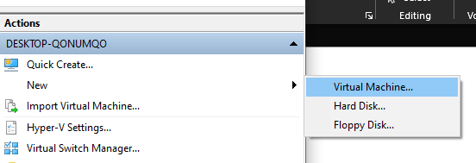
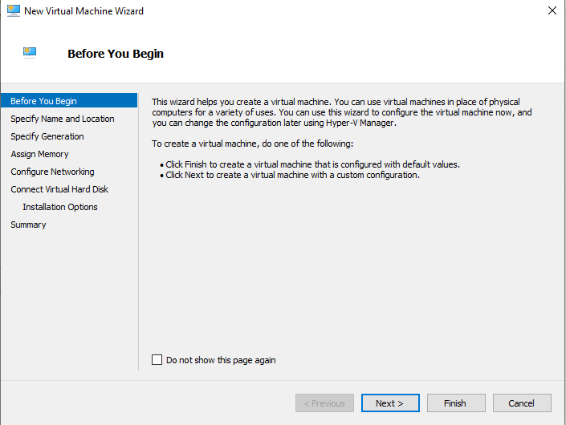
Specify Name: Define a name for your virtual machine, it can be anything you want, ideally keep it simple to something like “Win11” then click Next.
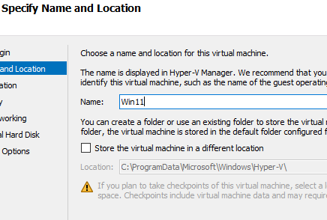
Specify Generation: Select the second option “generation 2” for this section as Win11 requires UEFI to install on. Then click Next.
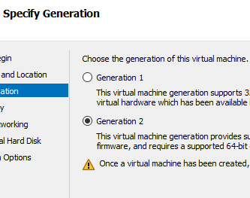
Assign Memory: Set the virtual memory/RAM to the following value of 4096 (4GB or more), this is the part of Windows 11 System requirements. Click Next.
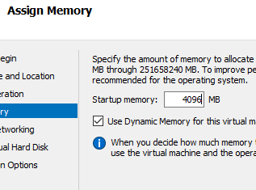
Configure Networking: Keep this option set as Not Connected and click Next – this will later help with installation.
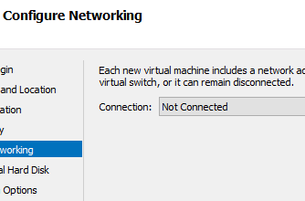
Connect Virtual Hard Disk: You can leave the below details as normal (127GB is more than enough for creating this VM). Click Next.
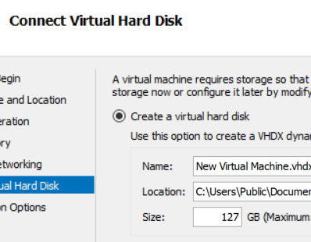
Installation Options: Select the 2nd option “install an operating system from a bootable image file” then click on Browse and select the location of the Windows 11.iso. Once selected click on Finish.
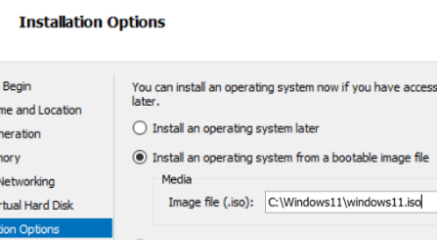
DO NOT TURN ON THE VM! MORE CONFIGURATION REQUIRED
On Hyper-V Manager right click on your windows 11 VM and select Settings.
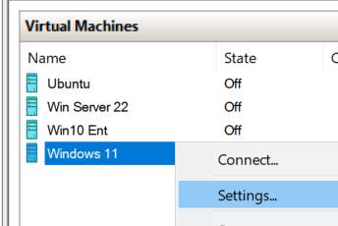
BIOS: Under this section highlight the legacy network adapter and press the move down button till its right at the bottom of the list.
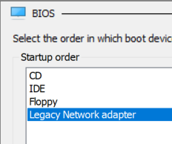
Security: Check the tick box option to enable Trusted Platform Module on this section.
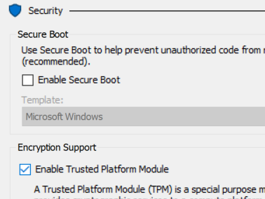
Processor: Set the number of processors to 2 or more.
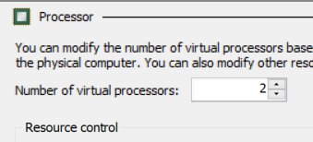
Final notes: Click OK at the bottom and you are done; now you can start your VM but be prepared to press any key when you see it on screen. Otherwise, it will freeze up as it will be looking for the OS on the network. If this happens you will need to reboot the VM and press any key again.
Run the installation of Windows accordingly. Ensure you choose WINDOWS 11 PRO Edition which should take 10 mins to install. Because you are not connected to the internet, you can create a local profile only on pro or enterprise editions. Home edition does not and would need you to register for a Microsoft account.
Activity 19: OS security and updates Q&A
- What are the primary functions of an operating system's security features?

- How does user authentication contribute to OS security?

- What is the role of firewalls in operating system security?

- Why is data encryption important in protecting sensitive information?

- How does malware protection integrated into an OS improve security?

- Why is security logging crucial for incident response and threat analysis?

- How do businesses use tools like WSUS to manage updates in large networks?

- What are the main differences between automatic updates and manual updates?

- Why are security patches critical in operating system updates?

Activity 20: System tools and resource management Q&A
Complete the tables:
System performance and monitoring Tools | Brief description
1. Task Manager
2. Resource Monitor
3. Performance Monitor
4. Event Viewer

System maintenance tools | Brief description
5. Disk Cleanup
6. Disk Management
7. System Restore
8. Defragment and Optimize Drives
9. Control Panel
10. Settings App
11. System Configuration (msconfig)
12. Registry Editor
13. Windows Defender
14. BitLocker
15. Windows Firewall
16. Command Prompt (cmd)
17. Windows PowerShell
18. Task Scheduler

Networking tools | Brief description
19. Network and Sharing Center
20. Network Troubleshooter

Activity 21: Event view and log files practical
A. Access the Event Viewer
- Open the Event Viewer:
  - Press Win + R, type eventvwr, and press Enter.
- Navigate through the log categories:
  - Expand Windows Logs to explore the following:
    - Application: Logs generated by installed applications.
    - Security: Audit logs for login attempts and resource access.
    - System: Events related to the operating system and drivers.
    - Setup: Logs related to OS setup activities.
    - Forwarded Events: Logs forwarded from other systems.
B. Filter and View Specific Logs
- Choose a log category (e.g., System).
- Click on Filter Current Log from the right-hand menu.
- Filter events by:
  - Level: Information, Warning, Error, or Critical.
  - Event ID: Specify an ID to view logs for specific events (e.g., Event ID 41 for kernel power issues).
  - Date/Time: Set a range to filter recent logs.
- Apply the filter and view the results.
C. Analyse a System Event
- Identify a recent Error or Warning event in the System log.
- Double-click the event to view its details, including:
  - General: A summary of the event.
  - Details: Technical data about the event.
- Take a screenshot of the event details for your records.
D. Export and Save Logs
- Select any log category (e.g., Security).
- Right-click on the log and choose Save All Events As.
- Save the file in .evtx format to a location of your choice.
- Optional: Save the log as a plain text or XML file for easier sharing or analysis.
E. Attach your screenshot below:

Activity 22: Types of network Q&A
Complete the table:
Type of Network | Description
PAN
LAN
MAN
WAN
GAN
SAN
CAN
HAN
BAN
WPAN
LPWAN

Activity 23: Networking models Q&A
Create simple diagrams that visualise the networking models list below and add them to the table. You can create your diagrams using applications such as PowerPoint or browser-based tools such as Draw.io.
Client-Server model

Centralized Networking Model

Distributed Networking Model

Peer-to-Peer (P2P) Networking Model

Hybrid Networking Model

Activity 24: Wireless networking Q&A
Refer to Microsoft Wi-Fi troubleshooting guidance to help you answer these questions:

- How does the physical layout of your home affect Wi-Fi performance?

- What steps can you take to improve Wi-Fi coverage in areas with weak signals?

- How can the placement of your router influence the strength and reliability of your Wi-Fi connection?

- What are the differences between the 2.4 GHz and 5 GHz Wi-Fi bands, and how should you choose between them?

- How can you identify and reduce sources of interference that may be impacting your Wi-Fi network?

- What role do building materials (such as walls and floors) play in Wi-Fi signal degradation, and how can you mitigate these effects?

- How can you use network speed tests to assess and improve your Wi-Fi performance throughout your home?

Activity 25: Subnetting practical
Open Packet Tracer along with the ‘Activity 25 Packet Tracer Subnetting.PKA’ file and apply your resolution. Identify and correct configuration in a wireless network.
Objectives
Given a network address with CIDR notation, calculate the first and last address in a specified range and determine the Subnet Mask.
Introduction
As you know, every Subnet has the following components:
- Network address
- Broadcast address
- A range of useable IP addresses
- Subnet Mask
Given an IP address with CIDR notation, your challenge is to determine the values associated with a specified Subnet. After performing your calculations, you will configure the devices to check your results.
Note: Remember to save any files once your activity is complete.
Topology
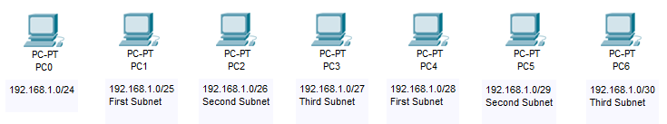
- Your calculations
Use the table below to record the answers to your calculations. The first three octets for each address have been entered for you.
Device | IP Address  (First IP address in the range) | IP Address  (Last IP address in the range) | Subnet Mask
PC0  192.168.1.0/24 | 192.168.1. | 192.168.1. | 255.255.255.
PC1  192.168.1.0/25  First subnet | 192.168.1. | 192.168.1. | 255.255.255.
PC2  192.168.1.0/26  Second subnet | 192.168.1. | 192.168.1. | 255.255.255.
PC3  192.168.1.0/27  Third subnet | 192.168.1. | 192.168.1. | 255.255.255.
PC4  192.168.1.0/28  First subnet | 192.168.1. | 192.168.1. | 255.255.255.
PC5  192.168.1.0/29  Second subnet | 192.168.1. | 192.168.1. | 255.255.255.
PC6  192.168.1.0/30  Third subnet | 192.168.1. | 192.168.1. | 255.255.255.

- Configure the devices
Once your table is complete:
- Select PC0>Desktop>IP Configuration
- Click Static
- Use your answers above to enter:
- IP Address (First IP address in the subnet range)
- Subnet Mask
- Default Gateway (Last IP address in the subnet range)
- Close the IP Configuration window
- Repeat steps 1 to 4 for the remaining PCs
- Check your results
If your configuration settings are all correct, you should see the following score:
Investigate and resolve any issues before continuing.

Activity 26: IPv6 Q&A
Complete the following multiple-choice questions.
1. The following IPv6 Address is an example of what?
2001:0db8:85a3:0000:0000:8a2e:0000:7334
- Teredo Tunnelling Address
- Link Local Address
- Global Unicast Address
- Multicast Address
2. The following IPv6 Address is an example of what?
fe80::200:5aee:feaa:20a2
- Loopback Address
- Link Local Address
- Global Unicast Address
- Anycast Address
3. The following IPv6 Address is an example of what?
2001:0dg8:82a3:0000:0000:6a2e:0000:7124
- Loopback Address
- Link Local Address
- Invalid Address
- Global Unicast Address
4. Which of the following Address Types is similar to an IPv4 Private Address?
- Link Local Address
- APIPA Address
- Global Unicast Address
- Unique Local Unicast Address
5. True or false, the following IPv6 Address is invalid:
fe80:0000:0000:0184:e9f8:a71b:0304
- True
- False
6. How do you correctly compress the following IPv6 address:
2001:0db8:0000:0000:0000:0000:0000:0c50
- 2001:0db8:0:0:0:0:0:0c50
- 2001:0db8::0c50
- 2001:db8::c50
- 2001:db8::c5
7. How do you correctly compress the following IPv6 address:
2001:0db8:0000:0000:b450:0000:0000:00b4
- 2001:db8::b450::b4
- 2001:db8::b450:0:0:b4
- 2001:db8::b45:0000:0000:b4
- 2001:db8:0:0:b450::b4
8. How do you correctly compress the following IPv6 address:
2001:0db8:00f0:0000:0000:03d0:0000:00ff
- 2001:0db8:00f0::3d0:0:00ff
- 2001:db8:f0:0:0:3d0:0:ff
- 2001:db8:f0::3d0:0:ff
- 2001:0db8:0f0:0:0:3d0:0:0ff
9. How do you correctly compress the following IPv6 address:
2001:0db8:0f3c:00d7:7dab:03d0:0000:00ff
- 2001:db8:f3c:d7:7dab:3d:0:ff
- 2001:db8:f3c:d7:7dab:3d0:0:ff
- 2001:db8:f3c:d7:7dab:3d0::ff
- 2001:0db8:0f3c:00d7:7dab:03d::00ff
10. How do you access your IPv6 webserver at 2001:db8::8080 on port 8080 using a web browser?
- http://2001:db8::8080:8080
- http://2001:0db8:0000:0000:0000:0000:0000:8080:8080
- http://[2001:db8::8080]:8080
- You cannot use the IPv6 address, you have to rely on DNS.

Activity 27: Network services Q&A
Protocol | Full Name | Port Number | Home/Office/Both
HTTP
HTTPS
DHCP
DNS
Kerberos
HLS
SNMP
NTP
LDAP
SMB
FTP
VPN
SSH
IMAP
AFP
RADIUS
XMPP
SMTP

Activity 28: DHCP
Imagine you're on an Avanti train traveling from London to Manchester, and your laptop is connected to the train's onboard Wi-Fi. The train's network uses DHCP to assign IP addresses to passengers.
- At the start of the journey, your laptop successfully receives a DHCP lease with a lease time of 60 minutes.
- During the journey, the train stops at Birmingham, and the onboard Wi-Fi briefly disconnects due to a system reboot.
- While the Wi-Fi is down, your laptop assigns itself an APIPA address (169.254.x.x).
Questions:
- What happens to your DHCP lease when the Wi-Fi reconnects after the stop?
- Will your device request a new lease, renew the existing lease, or continue using the APIPA address?
- Explain how DHCP handles this scenario, including the role of T1 and T2 timers and the potential effects on network connectivity.
Hint:
Consider the duration of the Wi-Fi downtime, whether the DHCP lease is still valid, and how your laptop behaves when transitioning between APIPA and DHCP environments.

Activity 29: DNS
Open Command Prompt or PowerShell and complete the following:
1. Query an A Record:
Use nslookup to find the IPv4 address of a domain name (www.google.com).
nslookup www.google.com
What result did you get:

2. Find an MX Record:
Look up the Mail Exchange (MX) records for a domain (yahoo.com).
nslookup -type=mx yahoo.com
What result did you get:

3. Check a CNAME Record:
Identify the canonical name (CNAME) of a subdomain (www.example.com).
nslookup -type=cname www.example.com
What result did you get:

4. Query NS Records for a Domain:
Find the name servers responsible for a domain (example.com)
nslookup -type=ns example.com
What result did you get:

5. Retrieve TXT Records
Extract TXT records, often used for SPF or verification (google.com)
nslookup -type=txt google.com
What result did you get:

6. Reverse Lookup with a PTR Record
Perform a reverse DNS lookup to find the domain name associated with an IP address (8.8.8.8)
nslookup 8.8.8.8
What result did you get:

7. Specify a Different DNS Server:
Query the DNS records for a domain using a public DNS server like Google DNS (8.8.8.8).
nslookup example.com 8.8.8.8
What result did you get:

8. Find Authoritative DNS Servers:
Use nslookup to determine the authoritative name servers for a domain.
nslookup -type=soa example.com
What result did you get:

9. Find Authoritative DNS Servers:
Use nslookup to determine the authoritative name servers for a domain.
nslookup -type=soa example.com
What result did you get:

Click on PC1 to establish the source. Move your cursor to PC11 and click to establish the destination.
Click Auto Capture / Play from the Play Controls area of the Simulation Panel and observe the traffic generated by the Ping request.
Repeat the test for the following:
Source: PC12 Destination: PC2
Provide a summary of your observations and creations:



